Project 7 Design Document

**Program Requirements**

This project will use a series of User-Created functions to accept different school grades from a user (includes of exams, projects, assignments, and quizzes). You will use these functions to accept the input, calculate the averages of all the assignment categories, and then calculate the current course of the student’s grade based on the weight percentages given by the professor.

Update the solution to Project #6 with a new function that, given the current grades (using the same technique as for Project #6), calculates and prints out the required score on the final exam if you want to receive a 92.5, an 82.5, a 72.5, and a 62.5 semester grade.

**Program Inputs**

* Quiz grades
  + quizGrades
  + int value
* Assignment grades
  + assignmentGrade
  + int value
* Exam grades
  + examGrades
  + int value
* Project grades
  + projectGrades
  + int value

**Program Outputs**

* Quiz average
  + quizAvg
  + double value
* Assignment average
  + assignmentAvg
  + double value
* Exam average
  + examAvg
  + double value
* Project average
  + projectAvg
  + double value
* Current grade
  + currentGrade
  + double value
* Final grade
  + finalGrade
  + double value

**Test Plan**

**Test Plan**

* Test for validity of the program
* Ex:
  + **Enter your quiz grades (-1 to end input):**
  + **100 95 90 85 -1**
  + **Enter your assignment grades (-1 to end input):**
  + **50 100 100 25 0 -1**
  + **Enter your exam grades (-1 to end input):**
  + **65 -1**
  + **Enter your project grades (-1 to end input):**
  + **80 93 75 -1**
  + **Your quiz average: 92.5**
  + **Your assignment average: 55**
  + **Your exam average: 65**
  + **Your project average: 82.6667**
  + **Your current grade in this course is: 74.4271**
  + **To make a 92.5 in this class you would need to make a: 164.7916**
  + **It is impossible to earn that grade**
  + **To make a 82.5 in this class you would need to make a: 114.7916**
  + **It is impossible to earn that grade**
  + **To make a 72.5 in this class you would need to make a: 64.4916**
  + **To make a 62.5 in this class you would need to make a: 14.7916**
* Ex 2:
  + **Enter your quiz grades (-1 to end input):**
  + **95 82 76 83 -1**
  + **Enter your assignment grades (-1 to end input):**
  + **75 100 100 65 90 -1**
  + **Enter your exam grades (-1 to end input):**
  + **83 -1**
  + **Enter your project grades (-1 to end input):**
  + **95 75 75 -1**
  + **Your quiz average: 84**
  + **Your assignment average: 86**
  + **Your exam average: 83**
  + **Your project average: 81.6667**
  + **Your current grade in this course is: 83.3**
  + **To make a 92.5 in this class you would need to make a: 135.8332**
  + **It is impossible to earn that grade**
  + **To make a 82.5 in this class you would need to make a: 85.8332**
  + **To make a 72.5 in this class you would need to make a: 64.4916**
  + **To make a 62.5 in this class you would need to make a: 14.7916**
* Test sentinel value
* Ex:
  + **Enter your quiz grades (-1 to end input):**
  + **100 95 90 85 -1**
  + **Enter your assignment grades (-1 to end input):**
  + **50 100 100 25 0 -1**
  + **Enter your exam grades (-1 to end input):**
  + **65 -1**
  + **Enter your project grades (-1 to end input):**
  + **80 93 75 -1**
  + **Your quiz average: 92.5**
  + **Your assignment average: 55**
  + **Your exam average: 65**
  + **Your project average: 82.6667**
  + **Your current grade in this course is: 74.4271**
  + **To make a 92.5 in this class you would need to make a: 164.7916**
  + **It is impossible to earn that grade**
  + **To make a 82.5 in this class you would need to make a: 114.7916**
  + **It is impossible to earn that grade**
  + **To make a 72.5 in this class you would need to make a: 64.4916**
  + **To make a 62.5 in this class you would need to make a: 14.7916**
* Ex 2:
  + **Enter your quiz grades (-1 to end input):**
  + **95 82 76 83 -1**
  + **Enter your assignment grades (-1 to end input):**
  + **75 100 100 65 90 -1**
  + **Enter your exam grades (-1 to end input):**
  + **83 -1**
  + **Enter your project grades (-1 to end input):**
  + **95 75 75 -1**
  + **Your quiz average: 84**
  + **Your assignment average: 86**
  + **Your exam average: 83**
  + **Your project average: 81.6667**
  + **Your current grade in this course is: 83.3**
  + **To make a 92.5 in this class you would need to make a: 135.8332**
  + **It is impossible to earn that grade**
  + **To make a 82.5 in this class you would need to make a: 85.8332**
  + **To make a 72.5 in this class you would need to make a: 64.4916**
  + **To make a 62.5 in this class you would need to make a: 14.7916**
* Test for correct calculations
* Ex:
  + **Enter your quiz grades (-1 to end input):**
  + **100 95 90 85 -1**
  + **Enter your assignment grades (-1 to end input):**
  + **50 100 100 25 0 -1**
  + **Enter your exam grades (-1 to end input):**
  + **65 -1**
  + **Enter your project grades (-1 to end input):**
  + **80 93 75 -1**
  + **Your quiz average: 92.5**
  + **Your assignment average: 55**
  + **Your exam average: 65**
  + **Your project average: 82.6667**
  + **Your current grade in this course is: 74.4271**
  + **To make a 92.5 in this class you would need to make a: 164.7916**
  + **It is impossible to earn that grade**
  + **To make a 82.5 in this class you would need to make a: 114.7916**
  + **It is impossible to earn that grade**
  + **To make a 72.5 in this class you would need to make a: 64.4916**
  + **To make a 62.5 in this class you would need to make a: 14.7916**
* Ex 2:
  + **Enter your quiz grades (-1 to end input):**
  + **95 82 76 83 -1**
  + **Enter your assignment grades (-1 to end input):**
  + **75 100 100 65 90 -1**
  + **Enter your exam grades (-1 to end input):**
  + **83 -1**
  + **Enter your project grades (-1 to end input):**
  + **95 75 75 -1**
  + **Your quiz average: 84**
  + **Your assignment average: 86**
  + **Your exam average: 83**
  + **Your project average: 81.6667**
  + **Your current grade in this course is: 83.3**
  + **To make a 92.5 in this class you would need to make a: 135.8332**
  + **It is impossible to earn that grade**
  + **To make a 82.5 in this class you would need to make a: 85.8332**
  + **To make a 72.5 in this class you would need to make a: 64.4916**
  + **To make a 62.5 in this class you would need to make a: 14.7916**
* Test for correct number of inputs
* Ex:
  + **Enter your quiz grades (-1 to end input):**
  + **100 95 90 85 -1**
  + **Enter your assignment grades (-1 to end input):**
  + **50 100 100 25 0 -1**
  + **Enter your exam grades (-1 to end input):**
  + **65 -1**
  + **Enter your project grades (-1 to end input):**
  + **80 93 75 -1**
  + **Your quiz average: 92.5**
  + **Your assignment average: 55**
  + **Your exam average: 65**
  + **Your project average: 82.6667**
  + **Your current grade in this course is: 74.4271**
  + **To make a 92.5 in this class you would need to make a: 164.7916**
  + **It is impossible to earn that grade**
  + **To make a 82.5 in this class you would need to make a: 114.7916**
  + **It is impossible to earn that grade**
  + **To make a 72.5 in this class you would need to make a: 64.4916**
  + **To make a 62.5 in this class you would need to make a: 14.7916**
* Ex 2:
  + **Enter your quiz grades (-1 to end input):**
  + **95 82 76 83 -1**
  + **Enter your assignment grades (-1 to end input):**
  + **75 100 100 65 90 -1**
  + **Enter your exam grades (-1 to end input):**
  + **83 -1**
  + **Enter your project grades (-1 to end input):**
  + **95 75 75 -1**
  + **Your quiz average: 84**
  + **Your assignment average: 86**
  + **Your exam average: 83**
  + **Your project average: 81.6667**
  + **Your current grade in this course is: 83.3**
  + **To make a 92.5 in this class you would need to make a: 135.8332**
  + **It is impossible to earn that grade**
  + **To make a 82.5 in this class you would need to make a: 85.8332**
  + **To make a 72.5 in this class you would need to make a: 64.4916**
  + **To make a 62.5 in this class you would need to make a: 14.7916**
* **Test for impossibility of target grade**
* **Ex:**
  + **Enter your quiz grades (-1 to end input):**
  + **100 95 90 85 -1**
  + **Enter your assignment grades (-1 to end input):**
  + **50 100 100 25 0 -1**
  + **Enter your exam grades (-1 to end input):**
  + **65 -1**
  + **Enter your project grades (-1 to end input):**
  + **80 93 75 -1**
  + **Your quiz average: 92.5**
  + **Your assignment average: 55**
  + **Your exam average: 65**
  + **Your project average: 82.6667**
  + **Your current grade in this course is: 74.4271**
  + **To make a 92.5 in this class you would need to make a: 164.7916**
  + **It is impossible to earn that grade**
  + **To make a 82.5 in this class you would need to make a: 114.7916**
  + **It is impossible to earn that grade**
  + **To make a 72.5 in this class you would need to make a: 64.4916**
  + **To make a 62.5 in this class you would need to make a: 14.7916**
* **Ex 2:**
  + **Enter your quiz grades (-1 to end input):**
  + **95 82 76 83 -1**
  + **Enter your assignment grades (-1 to end input):**
  + **75 100 100 65 90 -1**
  + **Enter your exam grades (-1 to end input):**
  + **83 -1**
  + **Enter your project grades (-1 to end input):**
  + **95 75 75 -1**
  + **Your quiz average: 84**
  + **Your assignment average: 86**
  + **Your exam average: 83**
  + **Your project average: 81.6667**
  + **Your current grade in this course is: 83.3**
  + **To make a 92.5 in this class you would need to make a: 135.8332**
  + **It is impossible to earn that grade**
  + **To make a 82.5 in this class you would need to make a: 85.8332**
  + **To make a 72.5 in this class you would need to make a: 64.4916**
  + **To make a 62.5 in this class you would need to make a: 14.7916**

**Solution Overview**

First, include all necessary libraries (iostream), then include the standard namespace. Then, declare the following functions: void printPrompt(int a), double average(), double weightedAverage(double, double, double, double), void outputAverages(double, double, double, double), void finalNeeded(double, double&, double&, double&, double&), void printNecessary(double, double).

Then, include your main function as well as the following variables: double quizAvg, assignmentAvg, examAvg, projectAvg, currentGrade, finalGrade, and targetGrade, necA, necB, necC, necD. Then, create a while loop where if the count is less than or equal to 4, you will call printPrompt(count). Then, create a switch control structure that will receive the grades from the user based on the value of the count. If the count is 1, set quizAvg equal to the function call average(). If the count is 2, set assignmentAvg equal to average(). If the count is 3, set examAvg equal to average(). If the count is 4, set projectAvg equal to average(). Make sure to update the counter by 1 after the end of the while loop. After the while loop, then set currentGrade equal to the function call weightedAverage(quizAvg, assignmentAvg, examAvg, projectAvg). This will calculate the current grade of the student based on the weighted percentages given by the professor. Then, call the function outputAverages(currentGrade, quizAvg, assignmentAvg, examAvg, projectAvg).

Then, call the function finalNeeded(currentGrade, necA, necB, necC, necD).

Then, call the functions void printNecessary(92.5, necA), void printNecessary(82.5, necB), void printNecessary(72.5, necC), void printNecessary(62.5, necD).

After the main function, you will define all of the user-created functions. For void printPrompt(int a), you will prompt the user to input the grades mentioned above, but will not accept any input. For double average(), you will take input from the user, and then calculate the average of the inputs entered. For double weightedAverage(double, double, double, double), you will take the calculated values from average(), and find the weighted average of those four values. For void outputAverages(double, double, double, double, double), you will output all of your calculations, and it will have no outgoing data. For void finalNeeded(double currentGrade, double& scoreA, double& scoreB, double& scoreC, double& scoreD), you will use the current grade and calculate all the scores necessary to get the set grades (92.5, 82.5, 72.5, and 62.5). For void printNecessary(double targetGrade, double necessaryScore), you will print the output of the needed grades. Within this function, you will also need to detect for impossible score values and print a prompt with this. You will also detect if the person already earned the score within this function.

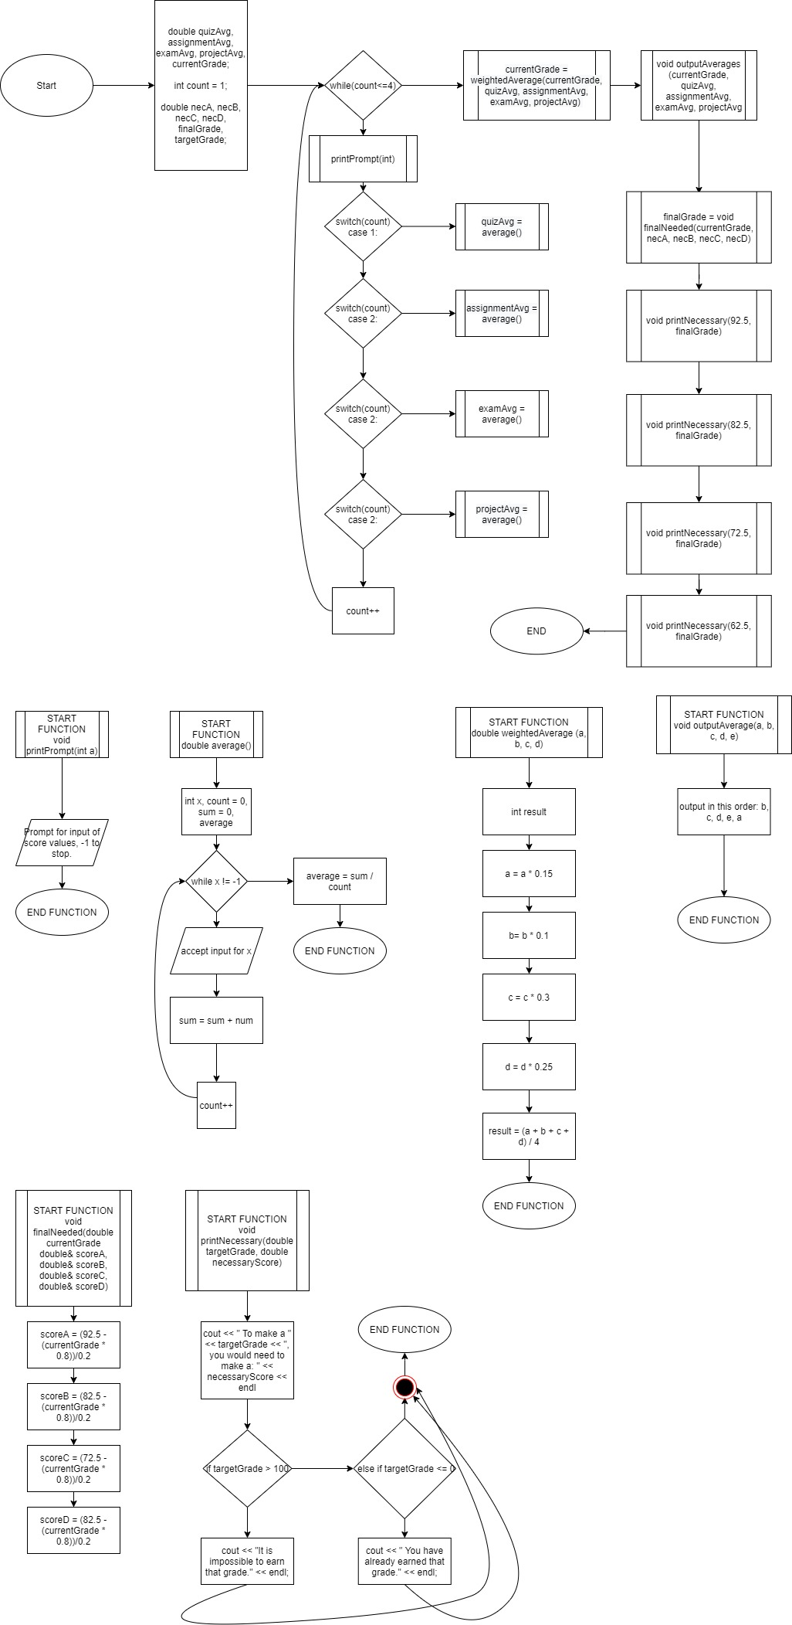**Algorithm Flowchart**